------------------------------------------------------

**GENERAL WEBSITE LAYOUT**

-------------------------------------------------------

*In order to understand how the website works we are going to start from the big picture of the website structure and move downward to where the content is actually written.*

*To start, all the website components are housed within the* ***bootstrap*** *folder under the pathway s*bcbon/internal/bon_website/bootstrap

**Background/Behind the Scenes Folders**

*Within the* ***bootstrap*** *folder there are several “background” folders, these are folders that conduct behind the scenes changes, more technical changes and computer generated changes by the website. For the most part these folders should not be touched. Especially the* ***_site*.** *In general all these folders have a _ in front of the folder name. They include the following:*

* *_data*
* *_includes*
* *_layouts*
* *_posts*
* *_site*
* *_template*

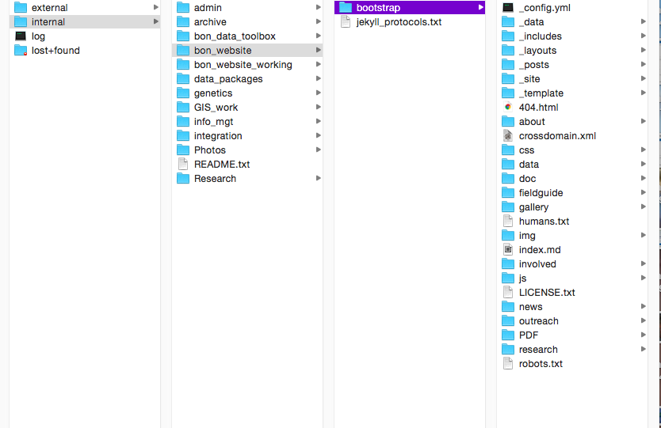

*For the most part changes are not often made in these folders because the website is already put together.*

**Website Content Folders**

*The website content is held within “website content folders” these folders are labeled based on the content they contain and their appearance on the website.*

*For example, the website has a* ***research*** *tab and under the research tab are other tabs including,* ***genomics, imagery*** *and* ***publications.*** *As seen in the photo below.* 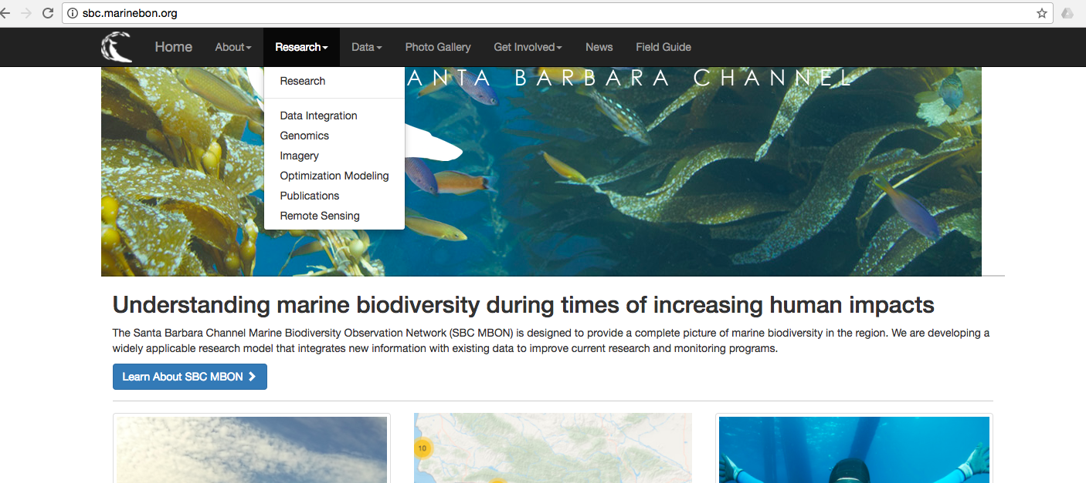

*Those tabs correspond to the folder found under the* ***research*** *folder in* ***bootstrap.***

*Then within each of the specific research folders there is an* ***index.md***  *file. This is the file where all the content for each research page is housed.* 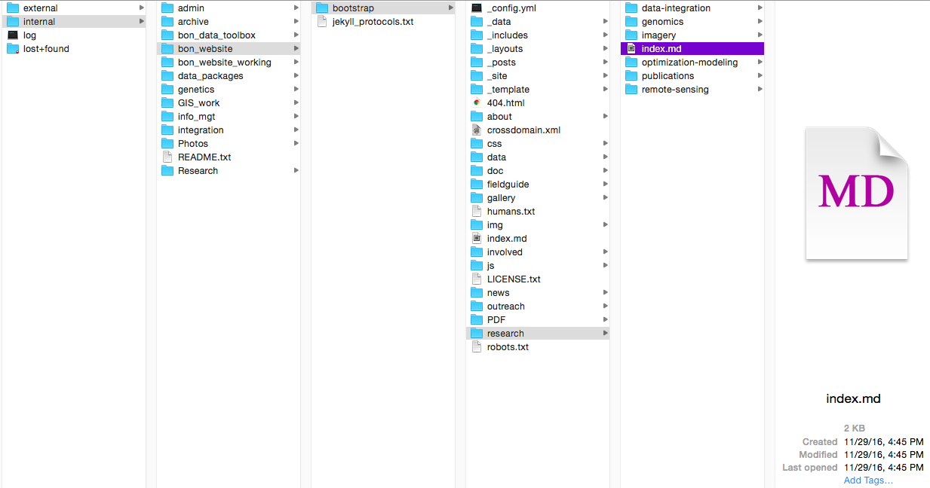

***Index.md*** *files are written in HTML and provide a place to put content and photos. They are the raw information if you will.*

*IF you are looking for the home page backgound image, the logo overlay on the home page or the small corner logo in the header bar are all found in the CSS file.*

*#intro-header{*

*padding-top: 150px;*

*padding-bottom: 150px;*

*text-align: center;*

*color: #fff;*

*background-image: url("../img/bgs/3788.jpg");*

*background-repeat: no-repeat;*

*background-position: center center;*

*background-size: 25% 25%*

*background-attachment: fixed;*

*z-index: 0;*

*#intro-logo{*

*width: 800px;*

*height: 320px;*

*margin: auto;*

*background-image: url("../img/logo/MBON_Logo_Full_White_800X320.png");*

*background-repeat: no-repeat;*

*background-position: center center;*

*background-attachment: scroll;*

*background-size: 800px 320px;*

*z-index: 0;*

*#navbar-logo{*

*width: 55px;*

*height: 40px;*

*background-image: url("../img/logo/MBON_Logo_icon_White_051517.png");*

*background-repeat: no-repeat;*

*background-position: top left;*

*background-attachment: scroll;*

*background-size: 40px 40px;*

*margin-top: -10px;*

*padding-right: 15px;*

--------------------------------------------------------------------

**HTML! IT’S REALLY NOT THAT HARD**

---------------------------------------------------------------------

*Yes you are going to have to teach yourself a little HTML. It can be a little daunting, especially if you have never done any coding before, however it is quite easy for what we are doing and there are lots of resources to help you accomplish your coding goals. Looking back and forth at the website and the code and seeing how things change is the best way to learn. It will be a little slow going at first but then gets quite fun when you learn how to manipulate things.*

*My favorite website is:*

<https://www.w3schools.com/html/default.asp>

*This website is great and can help you accomplish almost anything you want to do with HTML. Plus it provides a tutorial and allows you to play with the code on your own through examples that you can change.*

*The easiest way to create new HTML pages is to find one of the pages already created on the website and then copy and edit the HTML to fit your needs.*

***Most Common HTML Tags on the Website***

*HTML tags tell your browser what to do. Each thing you want to do to your content begins with an open tag <insert tag here> and ends with a closed tag </insert tag here> Below are some of the most common tags used and what they do. It is suggested that you also view these tags in context of a prepared HTML page in the* ***bootstrap*** *folder. Try* ***Research\index.md.***

***<p>*** This tag puts your text into separate paragraphs. Put the text you want to be contained in the paragraph between the two tags*.****</p>*** [***https://www.w3schools.com/tags/tag_p.asp***](https://www.w3schools.com/tags/tag_p.asp)

***<div>*** tag defines a division or a section in an HTML document. I usually work between the div tags that are in place from the template text I am modifying ***</div>*** [***https://www.w3schools.com/tags/tag_div.asp***](https://www.w3schools.com/tags/tag_div.asp)

***<h1>*** this is a heading tag. It changes the size and boldness of the text. It should be used for headings only. These headers go from h1 to h6, where h1 is the largest and h6 is the smallest ***<h1>*** [***https://www.w3schools.com/tags/tag_hn.asp***](https://www.w3schools.com/tags/tag_hn.asp)

***<img src= “*** {{site.url}}/img/find the image you want and put its name here" ***alt=***"this is where you put text you want to appear when an image does not appear, for example you could write image unavailable" **style="**width:128px;height:128px;">

*note that the {{site.url}}/img/ *will always remain the same. This links you back to the folder where images are without having to write out the whole path name.* [*https://www.w3schools.com/html/html_images.asp*](https://www.w3schools.com/html/html_images.asp)

***<br>*** This one is super simple, it creates a line break in the text with an actual line that is visible on the website.You do not need a closing tag for this one. <https://www.w3schools.com/tags/tag_br.asp>

***<a href=”***path name to another page you want to link to OR a website url***” target=”_blank”>***

*The last part of the tag target=”_blank” will open the link in a new browser window. If you want the current page to be redirected to the page you clicked on and not opened in a new browser simply delete this tag.*

[*https://www.w3schools.com/tags/att_a_href.asp*](https://www.w3schools.com/tags/att_a_href.asp)

[*https://www.w3schools.com/tags/att_a_target.asp*](https://www.w3schools.com/tags/att_a_target.asp)

**The following tags are used to make lists.**

***<ol>*** This is used to make ordered lists you have to inlay another tag to make the numbered bullet points

**<li>** this is a list item, put numbered text in between theses tags **</li>**

**</ol>** this tag has to be used to end the list

***<ul>*** This is used to make unordered lists, also known to normal people as bullet points :)

**<li>** you must include your bulleted points in list form just as you did above. **</li>**

**</ul>**  and as before you must close the tag <https://www.w3schools.com/html/html_lists.asp>

-------------------------------------------------------------

**TUTORIALS AND WEBSITE HELP**

--------------------------------------------------------------

**JEKYLL HOW TO**

<https://www.youtube.com/watch?v=iWowJBRMtpc>

**HTML HELP**

<https://www.w3schools.com/html/default.asp> The W3school will be your lifeline!